Welcome!
Date
Name
Spouse
Address
City
State Zip _________
Email

Please Contact By
❑ Card  Phone  Visit

Telephone Best Time to Call
Home ______________
Work ______________

Guest: First Time Second Time
Are you a church member: yes no
Church
City, State

Circle Appropriate Age/Grade Group(s)
Preschool: Ages: B-1 2-3 4-5
Children: Grades: K 1 2 3 4 5 6
Youth: Grades: 7 8 9 10 11 12
Adults: Ages:18-29 30s 40s 50s 60s+

How did you learn about our church?
Newspaper Friend Yellow Pages Mail
Other

I am a guest of:

New in the Community? Yes No
Names & ages of children at home

Weekly Service & Activity Schedule

Sept 2, 2018
9:30 a.m. New Commandment Kids
9:45 a.m. Sunday School
11:00 a.m. Worship Service
6:00 pm Evening Service

Week of Sept 2, 2018

Wednesday 6:30 pm…………………..…Meal/Bible Study
Friday 6:30 pm……………….…………..Men’s 42 Night

Sept
9……………………………....New Commandment Kids
9……………………………...…………Business Meeting
9-16………..Wk of Prayer – Mary Hill Davis Missions
23-29…………….………Global week of student prayer
2018 Week of Prayer for Texas Missions
& the Mary Hill Davis Offering
Operation Christmas Child Gift for Sept.

GAMES
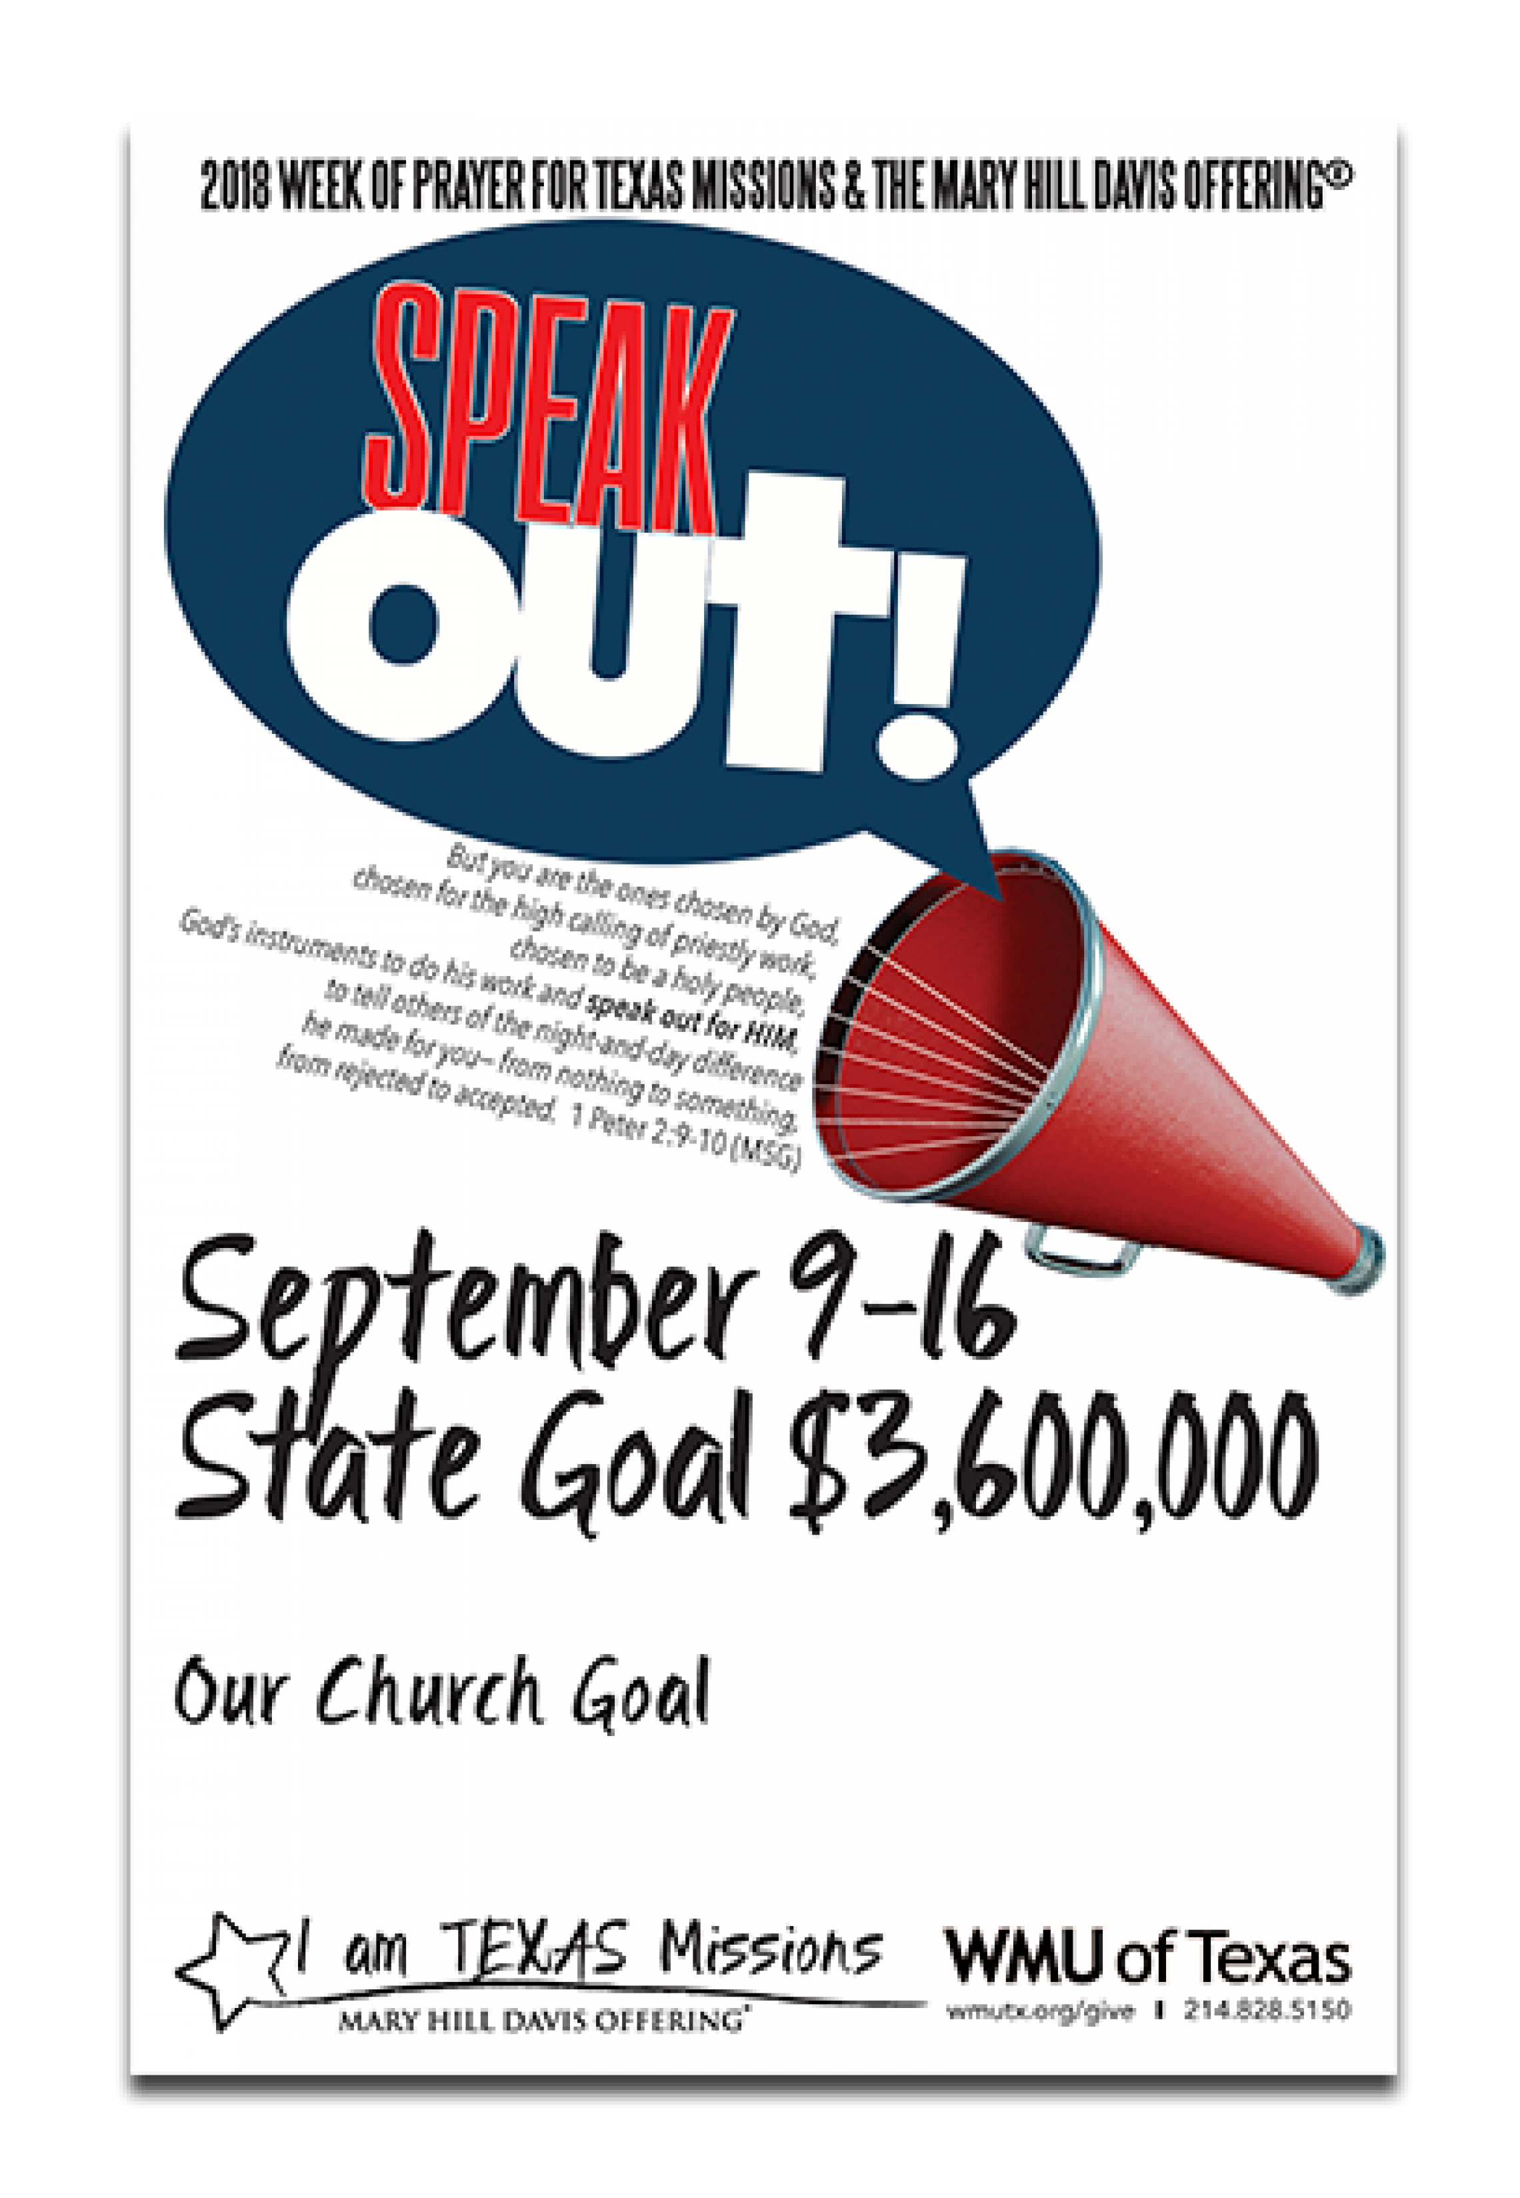

These include (small Etch a Sketch, Dominoes, checkers & other small games)


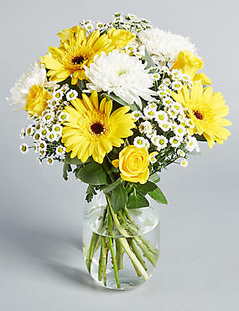
Flowers on the altar have been placed there in loving memory of
luke atwood

Knobbs Springs Baptist Church


Sept 2, 2018

Church Information:
KnobbsSpringsBC.com KnobbsSpringsBaptist@gmail.com

1662 CR 305, McDade, Texas 78650 512-273-2743

David Atwood, Pastor Cell 512-470-5098

Patti Radford, Office Manager Cell 512-968-7821

